**SQL Interview Quetions:**

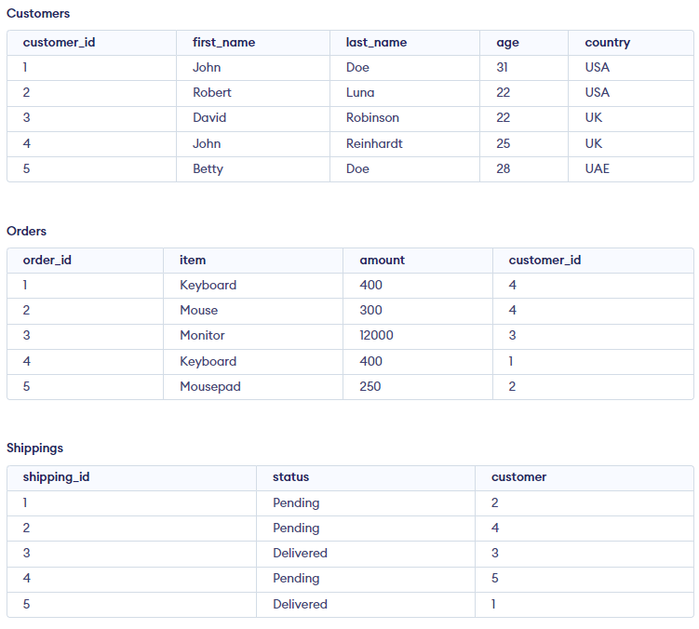

1. Find Max and Min age of customer:

* Select max(age),min(age) from customers;

1. Find Top value from customers:

* SELECT * FROM Customers ORDER BY customer_id ASC LIMIT 1;

1. Find Last value from customers:

* SELECT * FROM Customers ORDER BY customer_id DESC LIMIT 1;

1. Find even rows from table

* select * from customers where customer_id%2==0;

1. Find odd rows from table

* select * from customers where customer_id%2!=0

1. Find highest age of customer

* select max(age) from customers;

1. Find second highest age of customer

* select max(age) from customers where age not in (select max(age) from customers);
* select min(age) from customers where age not in (select min(age) from customers);

1. Find N-th highest age of customer

* select age from customers order by age desc limit 1, 1; => second highest age
* select age from customers order by age desc limit 2, 1; => third highest age
* where limit 2, 1 means (n-1) where n = 3 highest age and print only 1 record

1. Find N-th lowest age of customer

* select age from customers order by age asc limit 1, 1; => second lowest age
* select age from customers order by age asc limit 2, 1; => third lowest age
* where limit 2, 1 means (n-1) where n = 3 lowest age and print only 1 record

1. Find maximum age of same name of customer

* Select max(age),first_name from customers group by first_name;

1. Find records of customers who’s name is john and age is 25

* Select * from customers where first_name=”john” and age=25;

1. Find records of customers who’s name

* start with j and end with n
* end with e of last name
* Select * from customers where first_name like ‘j%n’
* Select * from customers where last_name like ‘%e’

1. Find count of each customers with same name

* select count(first_name),first_name from Customers group by first_name;

1. Find distinct age of customer

* select distinct age from customers;

1. print record customer’s name in upper case

* select upper(first_name) from customers;

1. find customer’s name who order keyboard

* select distinct first_name from customers as c , orders as o where c.customer_id = o.customer_id and o.item = "Keyboard";

1. no of order’s pending status of customer

* select count(*) from shippings where status = “Pending”;

1. get first four character’s of customer last name

* select substring(last_name , 1, 4) from customers;

1. find customer whose age is between 20 to 27

* select * from customers where age between ‘20’ and ‘27’;

1. find top 3 maximum age of customer

* select * from customers order by age desc limit 2,3;

1. find customer’s last name start with ‘R’ with contains 7 alphabets

* select * from customers where last_name like “R_______”

1. find customer’s data without including age 22 and 31

* select * from customers where age not in (22,31);

1. find customer’s data who has shipping status as “ Delivered “ and order product is in ( monitor)

* select first_name , status from customers as c inner join shippings as s , orders o on c.customer_id =s.customer and c.customer_id = o.customer_id and s.status="Delivered" and o.item in ('Monitor');